Lab homework #1 **.**



**Name: Ikhtiyor**

**Student Number:201739011**

**Course: Data Communication.**

**Professor: WooseonKim.**



Socket programming using UDP connection This is a server receiving messge from client for test case.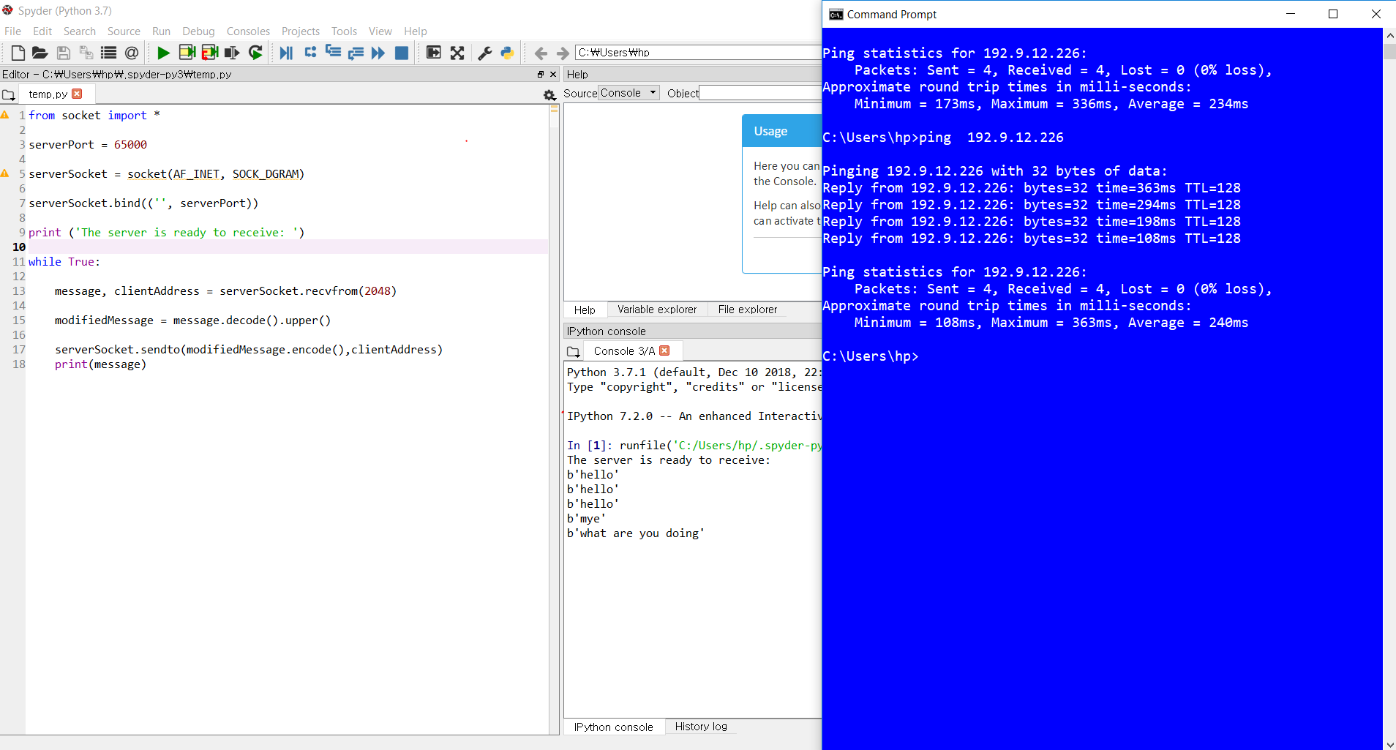

This is a client sending some message to server for test case.

